**“Metrology and Digital Image Processing in Dentistry”**

Francisco Javier Cuevas de la Rosa

Centro de Investigaciones en Óptica, A.C.

Miriam Rocha Navarro

miriamrocha@yahoo.com

Universidad de la Salle Bajio, A.C., Faculty of Dentistry

Manuel Garcia Salido

manueh452@hotmail.com

UNITEC Campus Leon

Manuel Rodríguez Villegas

mhrv99@gmail.com

Universidad De La Salle Bajío, A.C.

**Abstract.**

Metrological techniques using Digital Image Processing techniques have been extended into different fields of science such as optics, meteorology, mineralogy, agriculture, medicine among others. In the field of medicine, particularly in dentistry, it is important to perform different dental measurements to support the biometric work of specialists using panoramic radiographic images. Due to the poor capturing of these radiographic images several problems, such as poor contrast and quality, are generally present. Seeing as the detection of the dental area must be done using these images this chapter presents an algorithm that will assist in bettering image quality and makes the dental measurements needed. This is done by binarizing and establishing the teeth sections from an image to later use its histogram so that the statistics of gray intensities can be established and a suitable threshold for the detection of the intramaxillary section can be determined. Then a nonlinear function is fitted to the intradental section and different fit functions are tested using a random number of points within the intramaxillary area which performs a measurement of the size of the teeth. The method proposed fue applied to Panoramic digital radiographs of subjects with permanent dentition (≥ 12 years and < 30 years). The algorithm achieved an adjustment of 96% of the processed radiographs as a result from patients of the Universidad de la Salle Bajío School of Dentistry.

**Keywords:** Medical Imaging; Segmentation; Panoramic X-ray images; Biometrics; Digital Image Processing; Dental X-ray Segmentation; Polynomial Regression; Image Thresholding

1. **Introduction**

Medical specialists in dentristy often use image analysis, most commonly using radiographs, to assist in making diagnoses and as support for planning out major and minor surgeries for a patient’s treatment [1-14]. For this task, dentists ant other specialists have relied on computational algorithms of Digital Image Processing and Optical Metrology to carry out the recognition of benign and malignant structures in bone tissue, delimit organs and determine biometric characteristics that can be used in forensic tasks [15-18]. Unfortunately, due to problems in capturing radiographic images such as noise, quality of film, inadequate adjustments of X-ray equipment parameters and inexperience of radiological technicians, it is possible that medical specialist may incur errors during diagnosis.

Every day dental pathologies in patients continue to increase while the number of dentists worldwide is increasingly inadequate for the number of patients who require treatment in such a way that the development of automatic techniques for biometrics and dental metrology using Digital Image Processing and Artificial Intelligence is becoming of great importance. These techniques that carry out dental measurements are very useful to specialist because they assist in making diagnoses quicker and the follow-up after treatment easier [19-38]. Some of the most common ailments are periodontal disease, cavities, bone loss, chronic periapical abscess, periapical granuloma, radicular cyst, and malignant or benign tumors. Several of these conditions are monitored through dental biometric analysis using different X-ray images taken from different perspectives. The different perspectives used most frequently by dentists are periapical, bitewing and panoramic or orthopantograms. The panoramic perspective shows all the patient's teeth in one image making it possible to perform different measurements. Within the biometric process that must be done is the automatic detection and division of the intradental region and jaw (denture), since it is the starting point for performing dental segmentation and the detection of diastemas (intradental spacing).

It is also important to mention that there are other types of biometric applications using panoramic dental images where these algorithms can be applied. One alternative is using these dental images to identify people instead of using traditional methods such as face, iris, or fingerprint recognition in a forensic setting. Most often than not the traditional methods mentioned can be damaged in serious incidents such as car and air accidents to the point where they cannot be used for biometric identification, so analysis and recognition from dental images is an excellent alternative for these forensic cases [15-18,23].

Several researchers have worked on the development of manual and semi-automatic methods to detect and segment the jaw using different digital image processing algorithmic techniques. Several of the proposed methods require manual marking [15], which generates a disadvantage. Jain et al [16,17] proposed a method that uses an integral projection process of the image and Bayes rule to carry out the segmentation of the jaws and later an integration method for diastema detection. In [18] Wanat improved the method of Jain et al by using splines to divide the jaws. The Jain and Chen algorithm [16] has continued to be improved and semi-automatic methods have been proposed, such as the case of Harandi et al [19] show a method for segmentation of the intramaxillary region (IMR) through the use of modified geodesic active contour and different morphological operations on the X-ray image but it has some drawbacks due to the use of a cropped manually and that it works only with periapical images, in addition to the fact that the active detection of contours is an iterative process that can take up to 200 iterations. In [20] Hasan uses information from the gradient vector flow for automatic adjustment of snakes in the image, the k-means method to perform the segmentation process. This method has the drawback that it is necessary to set the number of classes and the thresholding conditions manually. On the other hand in [21] Haghanifar uses evolutionary computation and the Sauvola binarization algorithm to perform mandibular segmentation and separation, the jaw was divided using two steps, the calculation of the midpoints of the intradental zone and the use of snakes, which is computationally expensive. Recently, artificial intelligence and metaheuristic techniques have been used to carry out segmentation. In [22] Kong et al propose a method that uses deep learning to carry out the detection of the maxillary region through an encoder and decoder network (EED-Net). This method has the disadvantage that a marking and annotating process must be carried out by dental experts, which consumes the specialists' time and must be carried out manually, which complicates its application. Additionally, considerable time must be spent on training the EED-Net. On the other hand in [23] Boskurt et al fit an adjustment function is calculated with a metaheuristic process the Particle Swarm Optimization. This requires the manual selection of a series of points in the intramaxillary region and a high-order polynomial is passed whose biggest problem is the oscillations it suffers due to this.

In this chapter, a method of segmentation using a polynomial function adjustment with coefficient estimation by least squares approximation of the intramaxillary region (IMR) is proposed. The steps of the procedure are the following: a) Low-pass filter, b) Binarization using the gray level frequency histogram, c) Calculation of centroids, d) Detection of the intramaxillary section (IMR), e) Detection of random points in the intramaxillary region and f) Polynomial adjustment by adjustment of parameters using least squares. The method proposed fue applied to Panoramic digital radiographs of subjects with permanent dentition (≥ 12 years and < 30 years). The following sections show the operation of each procedure of the proposed method, the experiments carried out and the conclusions of the work.

1. **Automatic intramaxillary region detection method (IMR)**

During the automatic biometric dental process, to give a diagnosis or treatment, it is essential to locate the intramaxillary region and detect the teeth of both jaws. To achieve this, an algorithm that performs the following steps is proposed: a) Smoothing by median filtering b) Binarized with thresholding from the histogram c) Detection of centroids d) Determination of intramaxillary region. Each step of the proposed method is detailed below:

1. **Image smoothed**

Before starting with the IMR detection in the panoramic dental X-ray images, it is adequate to use spatial masks to perform spatial filtering processing. It is also possible to perform this same filtering but in the frequency domain by using the Fourier Transform although this is more laborious. In the case of panoramic dental X-ray images, it is prudent to carry out low-pass filtering that can reduce the noise effects related to high frequencies that are present in the Fourier domain because the high frequency components are related to the edges of objects, fine structures and noise contained in images. Carrying out this process will result in an unfocused or blurred image due to the removal of this information by low-pass filtering. For these purposes, a Gaussian-type kernel or an averaging filter (statistical mean) can be used to remove high frequencies but unfortunately in most cases they leave traces of noise and destroy important edges of the image. For this reason, for dental applications, it is preferred to work with the statistical method of the median since this method preserves the edges of the important dental pieces for segmentation tasks and dental biometry. In this method, the central pixel of the subimage mask around the (odd-sized) pixel is replaced by the statistical median instead of the value of the means or the application of the Gaussian spatial filter.

For IMR detection, it must be segmented into bright and dark regions. Given the a-priori information of the images obtained from an X-ray process, the brightest regions of the image will be related to both compact and spongy bone tissue and, on the other hand, the dark information is related to the other regions of the image among which is the IMR region of interest. It is important to eliminate high-frequency structures prior to the binarization process in order to improve its performance and avoid undesirable structures generated by spongy and compact bone tissue and additive noise contained in the image that prevent good IMR segmentation. To avoid this, a low pass filter is applied beforehand using the statistical median of a neighborhood of pixels of size 11x11. Using the set of values of the established neighborhood we obtain the element that leaves half of the smaller elements below it and the other half above it, in such a way that the high-frequency elements in the region remain on the shores. This filter is applied because it better maintains the contours of the regions when binarizing, including the IMR zone of interest.

1. **Thresholding**

After having applied the filter to eliminate high frequencies of the X-ray image that interfere in the detection of the regions, the next step is to carry out the binarization process by thresholding to start the segmentation of dark regions where the IMR region is located. It is important and very common to use a thresholding method to be able to carry out a process of segmentation and partitioning of the image in binary form from the gray intensity levels of the image in this dental panoramic X-ray case. For this case, the global information of the X-ray image is used depending on the value of the pixel. The intent of these methods is to allow starting from the pixel value *I*(*x,y*) at the spatial position of the digital dental panoramic X-ray image (*x,y*), where each l-bit pixel can contain values in the range of G ε [0,2l-1] representing the gray levels of the image. The idea of thresholding procedures is to map each pixel from an original value *I*: *M*x*N*→ *G* to a function of only two possible values B: *M*x*N*→{0,2l-1} from a threshold value *T* such that the thresholding image can be represented as:

$B\left(x,y\right)= \left\{\begin{aligned}0 if I\left(x,y\right)<T \\ 2^{l}-1 if I\left(x,y\right)≥T\end{aligned}\right.$. (1)

The intention is to find and design a robust criterion that can perform and be applied in a repeatable way the IMR segmentation to find an adequate threshold value *T* that can be used and ensure the detection of the region of interest depending on the value of each pixel in the original X-ray image *I*(*x,y*). To carry out the segmentation for the initial detection of the IMR, the thresholding procedure is applied to the entire dental X-ray image with a single threshold value to generate the partition into dark and bright regions.

The IMR has the attributes of having a large area compared to the average of the regions in addition to having a centroid close to the center of the image because the dentist focuses the area of ​​interest (teeth) in the capture process. of the X-ray image. For this, we perform a binarization considering the a-priori knowledge related to the fact that the concentration of bone tissue information is located in the bright section of the image and therefore recorded in the gray level frequency histogram and that the remaining regions including the region of interest (IMR) are located in the region related to the frequency of dark gray levels.

Carrying out experimentation, a threshold was located that correctly segments the intradental region. To do this, we determine the probability distribution function of gray levels from the calculation of the histogram using the expression:

$p_{i}=\frac{h_{i}}{MN}$, (2)

where *hi* is the frequency of occurrence of the gray level *i*, *M* x *N* is the resolution of the radiographic image and pi represents the probability of occurrence of the gray level, then we determine the cumulative probability

function using the expression:

$P_{k}=\sum_{i=0}^{k}{p_{i}} ,$ (3)

The optimal threshold detected by experimentation to determine the threshold T in the range of [0,255] where the IMR is adequately separated is when the cumulative probability function reaches 0.3, that is, the histogram represents 30% of the total resolution of the image, this can be expressed by the expression:

$T ϵ ArgMin \left(\sum_{i=0}^{T}{p_{i}>0.3}\right) .$ (4)

$T ϵ G$ $∀ G=0,1,2, … , 255$

From this threshold, the binarization of the image is carried out, from which several regions of different sizes related to the dark and bright information of the image are obtained. In the case of the IMR region of interest, it has the attribute of having an area with a larger dimension than the average of the other regions. In such a way that to carry out the identification of this region, we eliminate the regions with a smaller area less than the average of the total dark regions in order to speed up the detection process.

1. **Calculation of centroids and IMR detection**

After the binarized segmentation process of the dental X-ray images, it is important to determine some properties that can characterize them in order to discern the IMR region of interest in relation to the other partitions related to the dark regions of the X-ray image. One of the properties of the regions that are useful to carry out the IMR detection is undoubtedly the geometric information of the image and particularly its location of the centroids of the region. For this, it is necessary to calculate the areas of each region in the dark sections of the X-ray dental image and add the coordinates of these regions in rows and columns (*x,y*) in such a way as to average the location of the pixels in the *k* region *Rk*(*x,y*). From these images, the centroids $\left({\overline{X}}_{k},{\overline{Y}}_{k}\right)$ of each region *k* (*Rk*(.)) with area *Ak* are determinated by calculating the following mathematical expressions:

${\overline{X}}_{k}= \frac{\sum_{x=0}^{M}{\sum_{y=0}^{N}{xR_{k}(x,y)}}}{A_{k}} , {\overline{Y}}_{k}= \frac{\sum_{x=0}^{M}{\sum_{y=0}^{N}{yR_{k}(x,y)}}}{A_{k}} .$ (5)

Due to the fact that when performing the capture, the dental specialist centers the patient's teeth on the X-ray plate, we can determine the IMR region from that region whose centroid is closest to the center of the image, in such a way that the IMR region will be the region *k* with the minimum indicated distance, that is:

$k= \min_{k}\left(\sqrt{{\left({\overline{X}}_{k}-\frac{M}{2}\right)}^{2}+{\left({\overline{Y}}_{k}-\frac{M}{2}\right)}^{2}}\right) .$ (6)

1. **Polynomial fit to intramaxillary región**

Once the IMR intramaxillary region has been determined using the procedure outlined in the last process, the next step in the procedure consists of fitting a polynomial function expressed by:

$P_{m}(x)=a_{o}x^{0}+a_{1}x^{1}+a_{2}x^{2}+ ⋅⋅⋅ +a_{m}x^{m}$, (7)

that fits the patient's teeth from this region by fitting a smooth curve that minimizes the squared error *Q* of a sample of points from this region given by

$Q= \sum_{i}^{P}{[P_{m}(x_{i})-y_{i}]^{2}}$. (8)

For this, at least a sample of 2% of the points of the IMR region is used, that is, the number of points P will be greater than 0.2 of MxN. Then the following system of equations is solved to minimize the quadratic error

related to the points of the region and the fit polynomial:

$\left[\begin{matrix}n+1 & \sum{x_{i}} & \begin{matrix}\sum{{x_{i}}^{2}} & \begin{matrix}⋯ & \sum{{x_{i}}^{m}}\end{matrix}\end{matrix} \\ \sum{x_{i}} & \sum{{x_{i}}^{2}} & \begin{matrix}\sum{{x_{i}}^{3}} & \begin{matrix}… & \sum{{x_{i}}^{m+1}}\end{matrix}\end{matrix} \\ \begin{matrix}⋮ \\ \sum{{x_{i}}^{m}}\end{matrix} & \begin{matrix}⋮ \\ \sum{{x_{i}}^{m+1}}\end{matrix} & \begin{matrix}\begin{matrix}⋮ \\ \sum{{x_{i}}^{m+2}}\end{matrix} & \begin{matrix}\begin{matrix}⋮ \\ ⋯\end{matrix} & \begin{matrix}⋮ \\ \sum{{x_{i}}^{2m}}\end{matrix}\end{matrix}\end{matrix}\end{matrix}\right]\left[\begin{matrix}a_{0} \\ a_{1} \\ \begin{matrix}⋮ \\ a_{m}\end{matrix}\end{matrix}\right]= \left[\begin{matrix}\sum{y_{i}} \\ \sum{x_{i}y_{i}} \\ \begin{matrix}⋮ \\ \sum{{x_{i}}^{m}y_{i}}\end{matrix}\end{matrix}\right] ,$ (9)

where (*xi,yi*) represent the sampled points of the IMR region and the vector **a**=(*a0, a1, a2,…, am*) represents the coefficients of the fitted polynomial. A complete flowchart of the IMR region polynomial detection and fitting process is shown in **Figure** **1**.

**3. Experiments**

This section shows examples of the segmentation process carried out on images of patients from Universidad La Salle School of dentristy of León, Mexico. The equipment with which the images were captured is a Morita Veraview X800 X-ray equipment. The captured panoramic dental X-ray images have a resolution of 1935 x 1024 pixels obtained. **Figure 2(a)** shows the panoramic image obtained by the X-ray equipment. To evaluate the performance of the method, the established process was carried out on 50 panoramic radiographic images of patients who were found in an age range between 12 and 30 years of patients from the Universidad de La Salle Bajío School of Dentistry in León, Guanajuato, Mexico with the following inclusion and exclusion criteria:

*+Inclusion Criteria*

- Panoramic digital radiographs of subjects with permanent dentition (≥ 12 years and < 30 years).

- Subjects of both genres.

*+Exclusion criteria*

- Panoramic digital radiographs of subjects with teeth showing evidence of incisal or occlusal edge with restorative intervention, traumatic injury, or occlusal wear from bruxism.

- Radiographs showing mixed dentition or edentulism.

The first step in the procedure consists of filtering out high-frequency structures such as mandibular spongy and compact tissue and capture noise using a kernel that calculates the median of a window of size 11x11, the result of which is shown in **Figure 2(b)**.

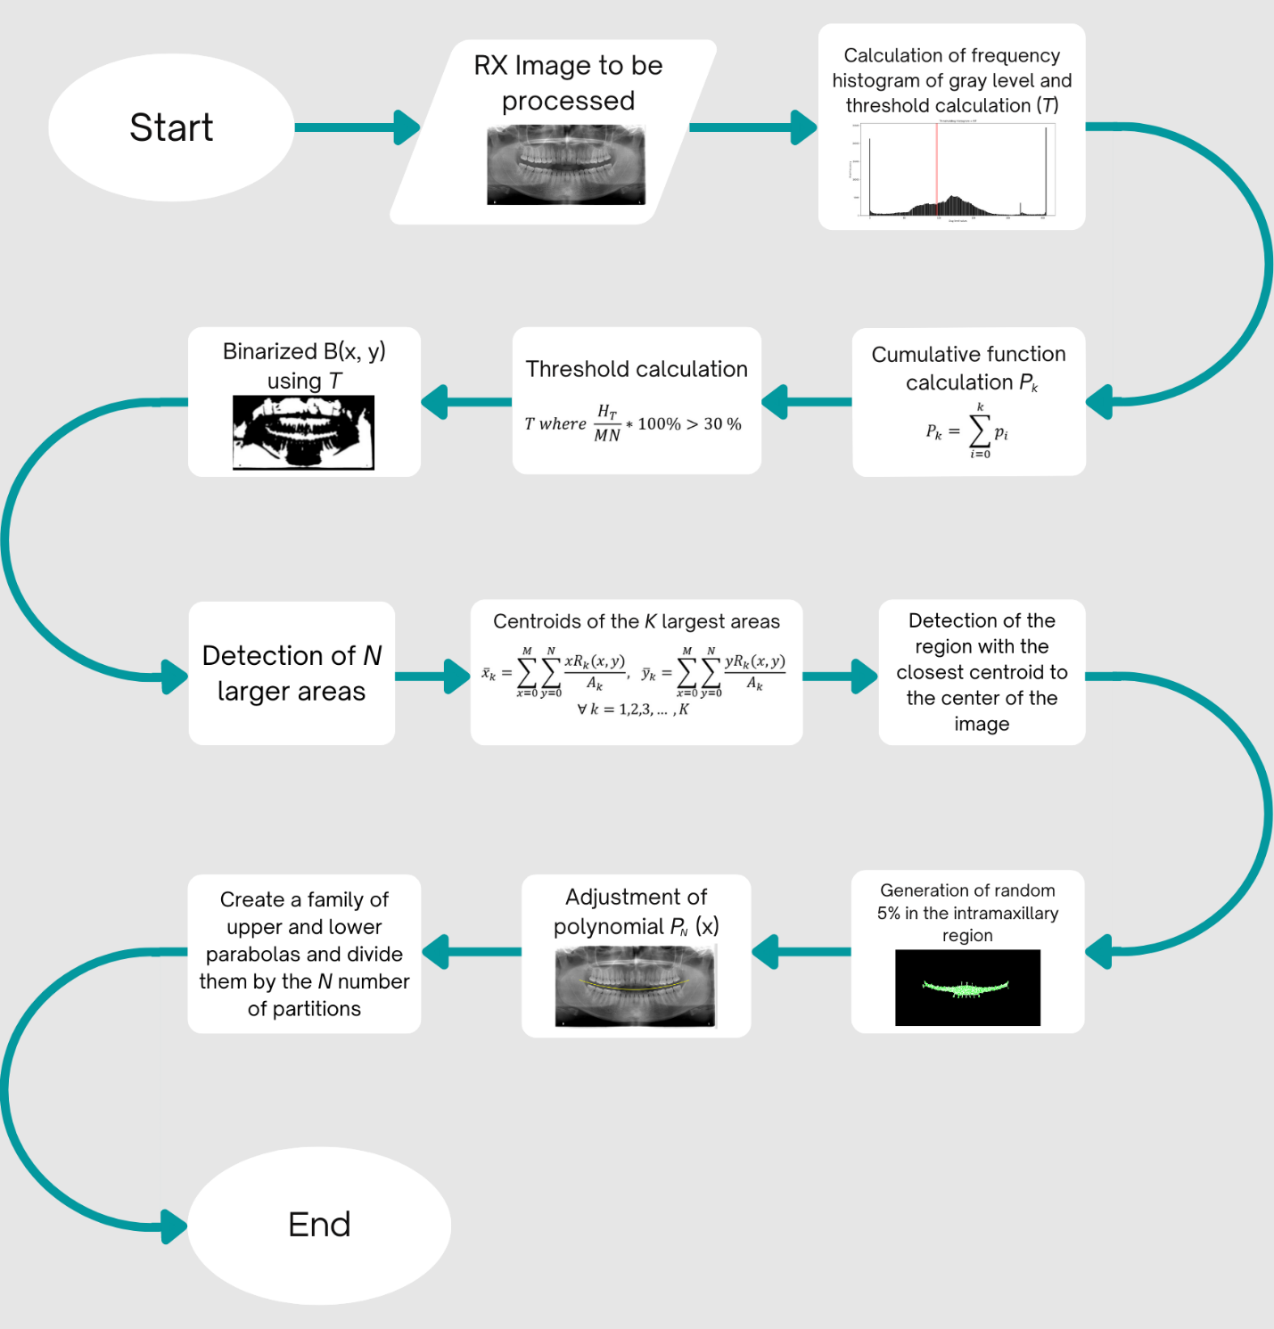

**Figure 1**.- Flow chart of the IMR denture and jaw segmentation process

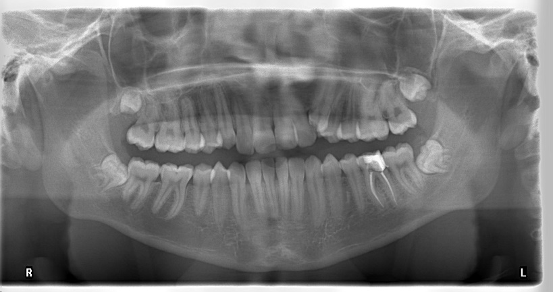

(a)

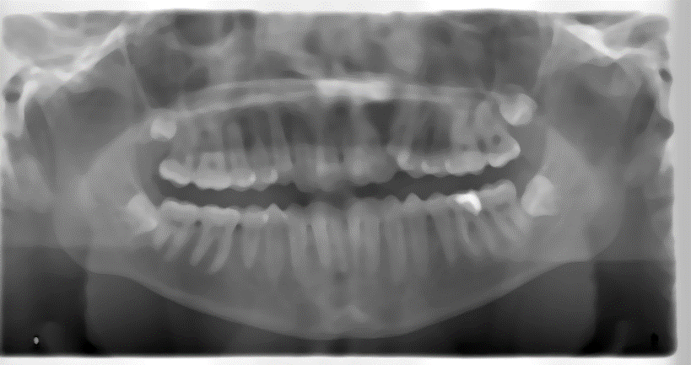

(b)

**Figure** 2.- (a) Original image (b) Smoothed image using median filter size 11x11 where high frequency structures (spongy and compact bone tissue) are removed

After applying the low-pass filter (median), we calculated the gray level frequency histogram of the panoramic dental image. From the generation of the histogram, we determine the probability distribution function using the equation 2 and determine the value of the threshold *T* when the cumulative probability function reaches or exceeds 0.3. The histogram of the image of **Figure 1(b)** and the detected threshold value (red line) is shown in **Figure** **3** and the binarized image with the threshold value *T* is shown in **Figure** **4**.

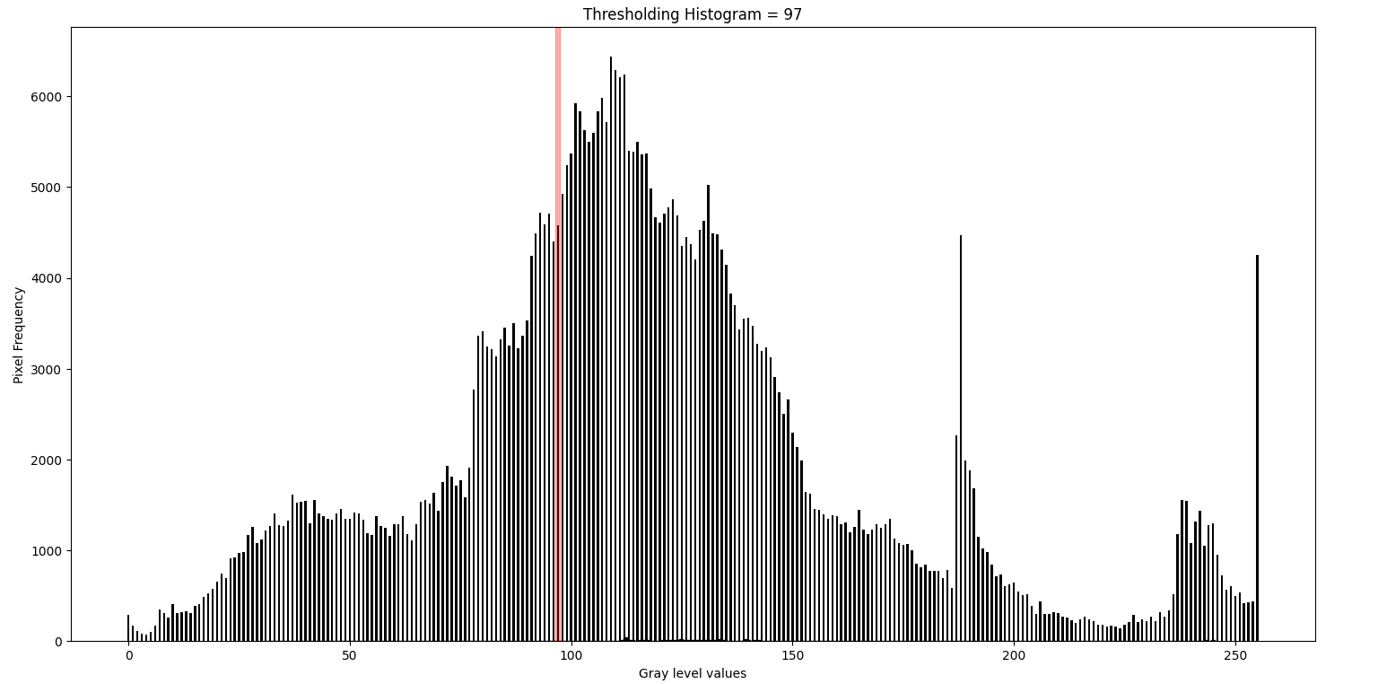

**Figure 3**.- Histogram with the frequency of occurrence of the gray levels of the image in Figure 1(b)



**Figure 4**.- Binarized image using a threshold of 30% from the cumulative function of the histogram of gray levels

The next step is to extract the centroids of the *K* largest regions and determine which of them is located closest to the center of the image, which is related to the IMR region of interest. **Figure 5** shows the largest areas from **Figure 4** and **Figure 6** shows the related centroids. Finally, **Figure 7** shows the selected IMR region. Once the IMR region has been determined, the next step in the procedure necessary to carry out the intramaxillary partition is to fit a polynomial (order 2) that smoothly divides the IMR. This is useful to carry out a subsequent process of dental biometric analysis. The fit is carried out by taking a sample of IMR points (2% of the points) and applying the optimization process to them to calculate the polynomial coefficients by estimating and reducing the mean square error by least squares. **Figure 8** shows the selected points and the fit of the curve (quadratic polynomial) that minimizes the error. **Figures 9** and **10** show the detection of the denture in both the lower and upper jaws on the original image. **Figures 11** shows 8 additional results with images of different patients by using of the proposed method.



**Figure 5**.- Selection of the regions with the largest area from the binarized

image in figure 4

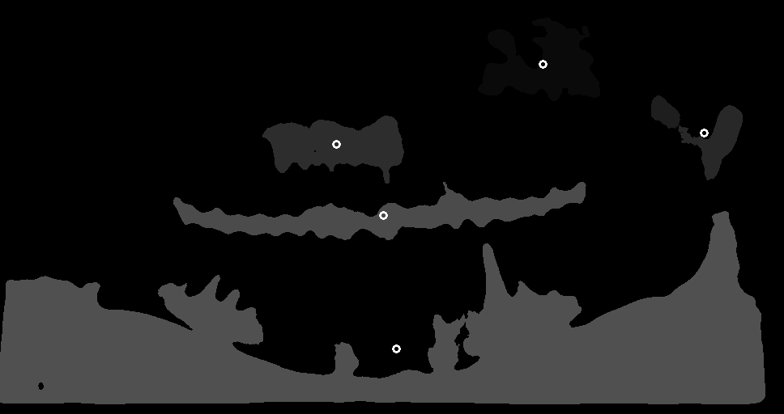

**Figure 6**.- Centroids of the dark regions of the original image



**Figure 7**.- Detection of the IMR region with centroid closest to the center of the image

The efficiency of the method was calculated based on the total number of regions IMR divided correctly according to the established manual marking and qualified by dental specialists and the one that did not meet the established segmentation requirements. Then, the efficiency equation *E* used for the proposed segmentation process was:

$E=\frac{C}{N}*100 \%$ (10)

where *C* is the number of X-ray panoramic dental images well segmented according to dental specialists and *N* is the total number of X-ray panoramic dental images processed. Using the previous equation, the efficiency of the method to detect the mandible and IMR was calculated, which turned out to be 96%.

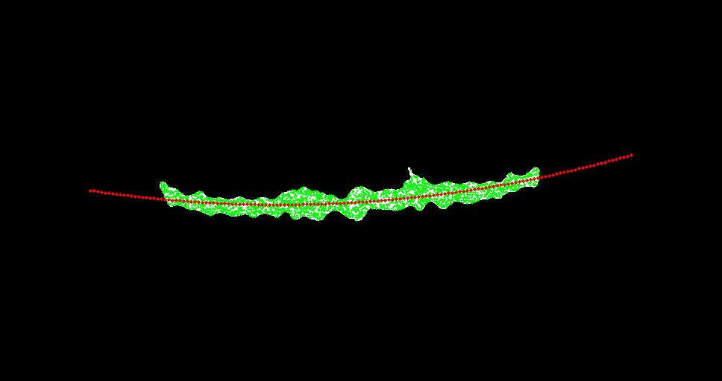

Figure 8.- Parabolic adjustment by point sampling in binarized IMR región

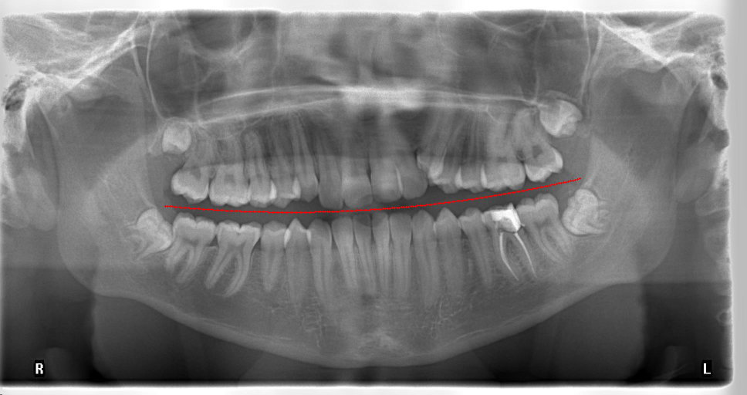

Figure 9.- Original image with a parabolic polynomial adjusted for division of the IMR section

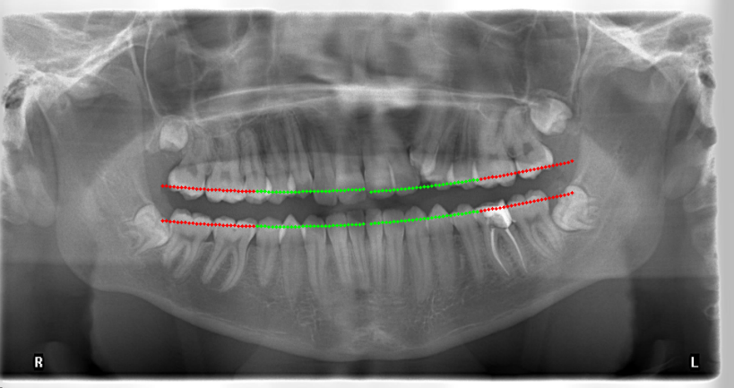

Figure 10.- Detection of the jaw in the lower and upper jaw

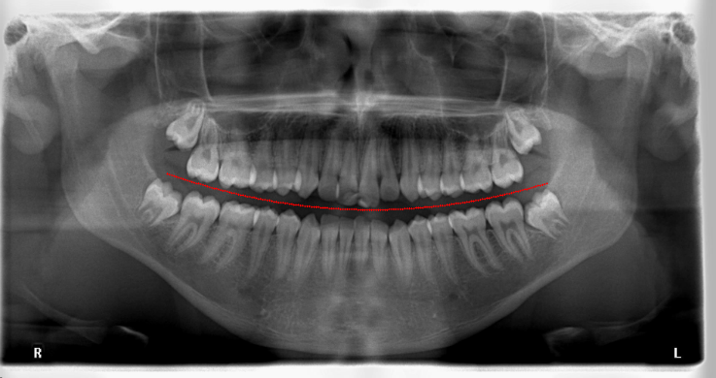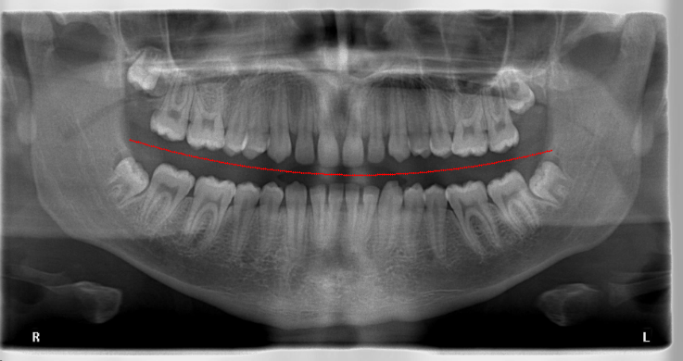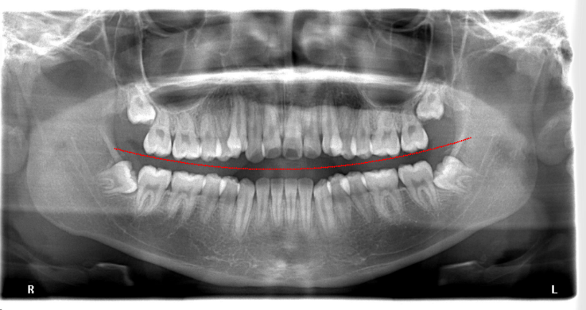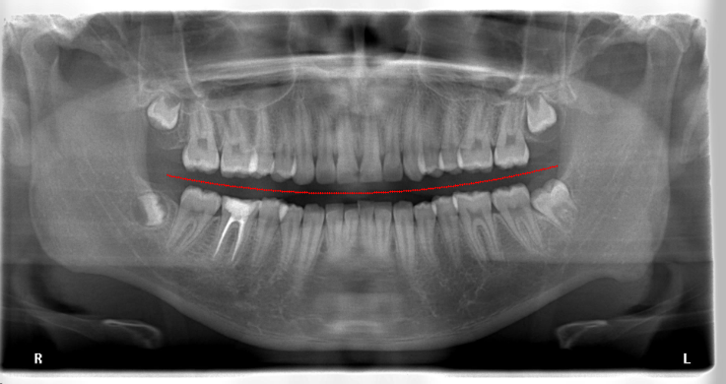

Figure 11.-Results using the proposed method applied to X-ray images from database with a curve fitting (Figure to be continued in next page)

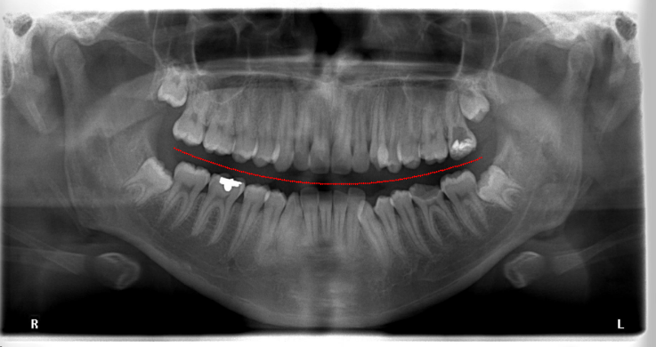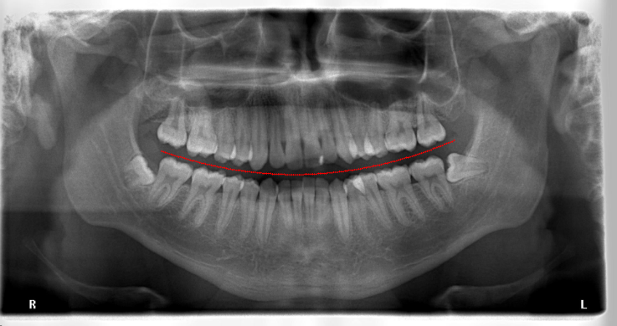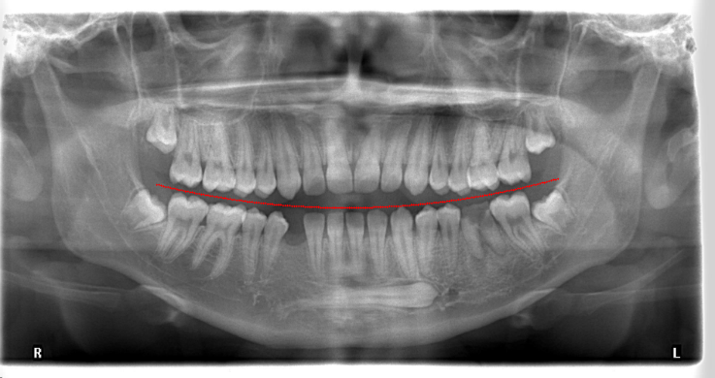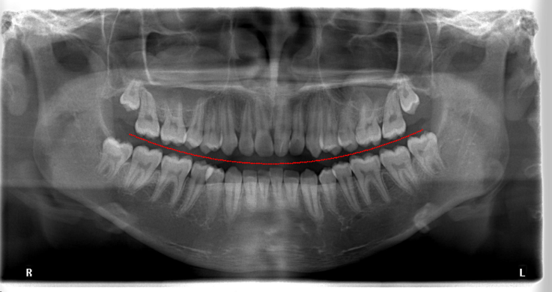

-Continuation of Figure 11.-Results using the proposed method applied to X-ray images from database with a curve fitting

1. **Conclusions**

It is shown that it is possible to use the proposed method to carry out the division and recognition of the intramaxillary region automatically from panoramic X-ray images without requiring the assistance of a dental specialist. Among the improvements proposed in this paper is the establishment of a thresholding method that adapts to the gray level statistics of the dental X-ray image of the patient in order to determine the area of interest to be detected (IMR). The established method calculates the density and cumulative probability functions to determine the region of bone tissue and absent regions of this tissue where the IMR is located. Likewise, a function is proposed that minimizes the distance from the centroids of the dark regions related to the intramaxillary space, eliminating the bright regions related to the spongy and compact bone tissue for IMR detection. Then a random sample of points from the IMR region is used to fit a quadratic polynomial that fits this region and the teeth. This procedure is carried out without requiring the assistance of a dental specialist. This detection method is useful for biometric measurements of teeth. The method was tested with 50 images and had an efficiency greater than 96%. Future work includes diastema detection and automatic segmentation of teeth for diagnostic and biometric tasks to monitor treatment and forensic applications, as well as a biometric dental support application for the daily work of dentists.

1. **Acknowledgments**

The authors wish to thank the Government of the state of Guanajuato in Mexico for supporting this research work under the fund IDEAGTO/CONV/079/2021-Ciencia Productiva- I+D Sociales y Humanidades en Sectores Estrategicos. We would like to thank the following people for their support: Martha Eugenia Fajardo Araujo, Juan Manuel Lopez, Fatima Hernandez Alvarez, Kenya Garcia Garcia, Hector Eduardo Gomez Perez, Alessio Sanchez Blasutti and Karina Guerrero Abrgo who were a fundamental part of the development of the work. We thank the following institutions whose facilities and financial support were important in the development of the research: Centro de Investigaciones en Óptica, A.C, Universidad de la Salle Bajio and Instituto Tecnologico y de Estudios Superiores de Monterrey, CONACYT and Universidad de Guanajuato.

**References**

[1] Iannucci JM, Howerton LJ. Dental Radiography: Principles and Techniques. 4th ed. Elsevier; 2011.

[2] Whaites E, Drage N. Essentials of Dental Radiography and Radiology. 5th ed. Elsevier; 2013.

[3] Gonzales RC, Woods RE. Digital Image Processing. 4th ed. Pearson; 2017.

[4] Fitzpatrick JM, Sonka M, eds. Handbook of Medical Imaging, Volume 2. Medical Image Processing and Analysis. SPIE; 2000. doi:10.1117/3.831079

[5] Risnes S, Segura JJ, Casado A, Jiménez-Rubio A. Enamel pearls and cervical enamel projections on 2 maxillary molars with localized periodontal disease: case report and histologic study. Oral Surg Oral Med Oral Pathol Oral Radiol Endod. 2000;89(4):493-497. doi:10.1016/s1079-2104(00)70131-4

[6] Hellén-Halme K, Nilsson M, Petersson A. Digital radiography in general dental practice: a field study. Dentomaxillofacial Radiol. 2007;36(5):249-255. doi:10.1259/dmfr/95125494

[7] Ennes J, Lara V. Comparative morphological analysis of the root developmental groove with the palato-gingival groove. Oral Diseases. 2004;10(6):378-382. doi:10.1111/j.1601-0825.2004.01009.x

[8] Anjna E, Kaur ER. Review of Image Segmentation Technique. International Journal of Advanced Research in Computer Science. 2017;8(4):36-39. doi:10.26483/IJARCS.V8I4.3691

[9] Bansal GJ. Digital radiography. A comparison with modern conventional imaging. Postgraduate Medical Journal. 2006;82(969):425-428. doi:10.1136/pgmj.2005.038448

[10] Fujita M, Kodera Y, Ogawa M, Wada T, Doi K. Digital image processing of periapical radiographs. Oral Surg Oral Med Oral Pathol. 1988;65(4):490-494. doi:10.1016/0030-4220(88)90365-9

[11] Gormez O, Yilmaz HH. Image post-processing in dental practice. Eur J Dent. 2009;3(4):343-347.

[12] Goldstein AR. Enamel pearls as contributing factor in periodontal breakdown. J Am Dent Assoc. 1979;99(2):210-211. doi:10.14219/jada.archive.1979.0258

[13] Said E, Fahmy GF, Nassar D, Ammar H. Dental X-ray image segmentation. Biometric Technology for Human Identification. Published online August 25, 2004:409-417. doi:10.1117/12.541658

[14] Stolojescu-Crisan C, Holban S. A Comparison of X-ray Image Segmentation Techniques. AECE. 2013;13(3):85-92. doi:10.4316/aece.2013.03014

[15] Omanovic M, Orchard JJ. Image Registration-Based Approach to Ranking Dental X-ray Images for Human Forensic Identification. Canadian Society of Forensic Science Journal. 2008;41(3):125-134. doi:10.1080/00085030.2008.10757170

[16] Jain AK, Chen H, Minut S. Dental Biometrics: Human Identification Using Dental Radiographs. Lecture Notes in Computer Science. Published online 2003:429-437. doi:10.1007/3-540-44887-x_51

[17] Jain AK, Chen H. Matching of dental X-ray images for human identification. Pattern Recognition. 2004;37(7):1519-1532. doi:10.1016/j.patcog.2003.12.016

[18] Wanat R. A Problem of Automatic Segmentation of Digital Dental Panoramic X-ray Images for Forensic Human Identification. The 15th Central European Seminar on Computer Graphics. Published online 2011.

[19] Harandi AA, Pourghassem H, Mahmoodian H. Upper and Lower Jaw Segmentation in Dental X-ray Image Using Modified Active Contour. 2011 International Conference on Intelligent Computation and Bio-Medical Instrumentation. Published online December 2011. doi:10.1109/icbmi.2011.88

[20] Hasan MM, Ismail W, Hassan R, Yoshitaka A. Automatic segmentation of jaw from panoramic dental X-ray images using GVF snakes. 2016 World Automation Congress (WAC). Published online July 2016. doi:10.1109/wac.2016.7583022

[21] Haghanifar A, Majdabadi MM, Ko SB. Automated Teeth Extraction from Dental Panoramic X-ray Images using Genetic Algorithm. 2020 IEEE International Symposium on Circuits and Systems (ISCAS). Published online October 2020. doi:10.1109/iscas45731.2020.9180937

[22] Kong Z, Xiong F, Zhang C, et al. Automated Maxillofacial Segmentation in Panoramic Dental X-ray Images Using an Efficient Encoder-Decoder Network. IEEE Access. 2020;8:207822-207833. doi:10.1109/access.2020.3037677

[23] Bozkurt MH, Karagol S. Jaw and Teeth Segmentation on the Panoramic X-ray Images for Dental Human Identification. J Digit Imaging. 2020;33(6):1410-1427. doi:10.1007/s10278-020-00380-8

[24] Sezgin M, Sankur B. Survey over image thresholding techniques and quantitative performance evaluation. J Electron Imaging. 2004;13(1):146. doi:10.1117/1.1631315

[25] Gayathri V, Menon HP. Challenges in Edge Extraction of Dental X-ray Images Using Image Processing Algorithms – A Review. International Journal of Computer Science and Information Technologies. 2014;5(4):5355-5357.

[26] Amer YY, Aqel MJ. An Efficient Segmentation Algorithm for Panoramic Dental Images. Procedia Computer Science. 2015;65:718-725. doi:10.1016/j.procs.2015.09.016

[27] Pham DL, Xu C, Prince JL. Current Methods in Medical Image Segmentation. Annu Rev Biomed Eng. 2000;2(1):315-337. doi:10.1146/annurev.bioeng.2.1.315

[28] Liao P, Fan Y, Nathanson D. Evaluation of maxillary anterior teeth width: A systematic review. J Prosthet Dent. 2019;122(3):275-281.e7. doi:10.1016/j.prosdent.2018.10.015

[29] McGowan S. Characteristics of Teeth: A Review of Size, Shape, Composition, and Appearance of Maxillary Anterior Teeth. Compend Contin Educ Dent. 2016;37(3):164-quiz172.

[30] Tsukiyama T, Marcushamer E, Griffin TJ, Arguello E, Magne P, Gallucci GO. Comparison of the anatomic crown width/length ratios of unworn and worn maxillary teeth in Asian and white subjects. J Prosthet Dent. 2012;107(1):11-16. doi:10.1016/S0022-3913(12)60009-2

[31] Orozco-Varo A, Arroyo-Cruz G, Martínez-de-Fuentes R, Jiménez-Castellanos E. Biometric analysis of the clinical crown and the width/length ratio in the maxillary anterior region. J Prosthet Dent. 2015;113(6):565-70.e2. doi:10.1016/j.prosdent.2014.11.006

[32] Al-Khatib AR, Rajion ZA, Masudi SM, Hassan R, Anderson PJ, Townsend GC. Tooth size and dental arch dimensions: a stereophotogrammetric study in Southeast Asian Malays. Orthod Craniofac Res. 2011;14(4):243-253. doi:10.1111/j.1601-6343.2011.01529.x

[33] Fernandes TM, Sathler R, Natalício GL, Henriques JF, Pinzan A. Comparison of mesiodistal tooth widths in Caucasian, African and Japanese individuals with Brazilian ancestry and normal occlusion. Dental Press J Orthod. 2013;18(3):130-135. doi:10.1590/s2176-94512013000300021

[34] Reynoso Rodríguez JL. Segmentation of Molars in Noisy Pantomograms Using Digital Image Processing Techniques. Master in Optomechatronics Thesis. León, Mexico: Centro de Investigaciones en Óptica; 2017.

[35] Garcia-Alcala L M, Segmentation of X-ray dental panoramic images by using of Digital Image Processing, Computer Sciences Engineering Bachelor Thesis. León, México: Instituto Tecnológico de Zamora, 2020

[36] Gomez, H E, Algortihm for the automatic segmentation of panoramic dental X-ray images by using of thecniques of Digital Image Processing and Artificial Intelligence, Technical Report on Professional residence of Computer Science Engineering at CIO, León, México: Instituto Tecnológico de Leon, 2021

[37] Hutter, F, Automated Machine Learning: Methods, Systems, Challenges. 1st ed. Springer International Publishing; 2019

[38] Computational Intelligence: An Introduction, 2nd Edition, Andries P. Engelbrecht Wiley: 2007